HCI OEL



Submitted To: Engr Hamid Ullah

Submitted By: Muhammad Bilawal
Department: C.S.E 6th Semester
Roll No & Reg No: 32 / 23MDSWE277

Dated: 24th May 2026
Cognitive Walkthrough Evaluation
AI Visibility & Brand Recommendation Optimization Platform (FYP)
Figma Dev Mode: https://www.figma.com/design/K8m14eCgzMJLV20KMtWvf3/AI-Visibility-Platform---FYP-Mockup?node-id=0-1&m=dev&t=o5WnxSK3uMCctljO-1
Figma Prototype (Clickable): https://www.figma.com/proto/K8m14eCgzMJLV20KMtWvf3/AI-Visibility-Platform---FYP-Mockup?node-id=0-1&t=o5WnxSK3uMCctljO-1
GitHub Link: https://github.com/bilawal-dev/HCI-Lab-Open-Ended-Lab-OEL
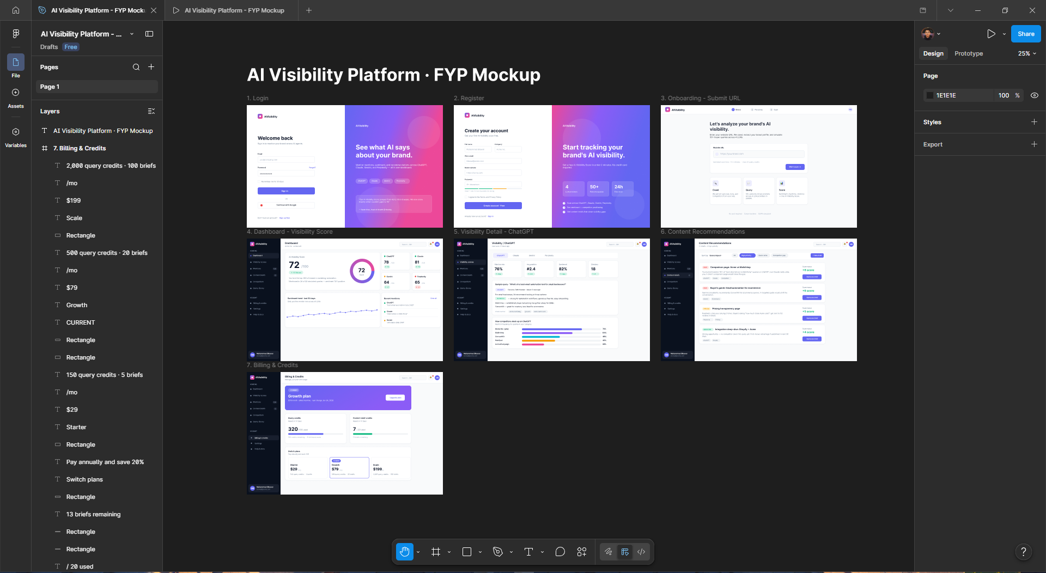
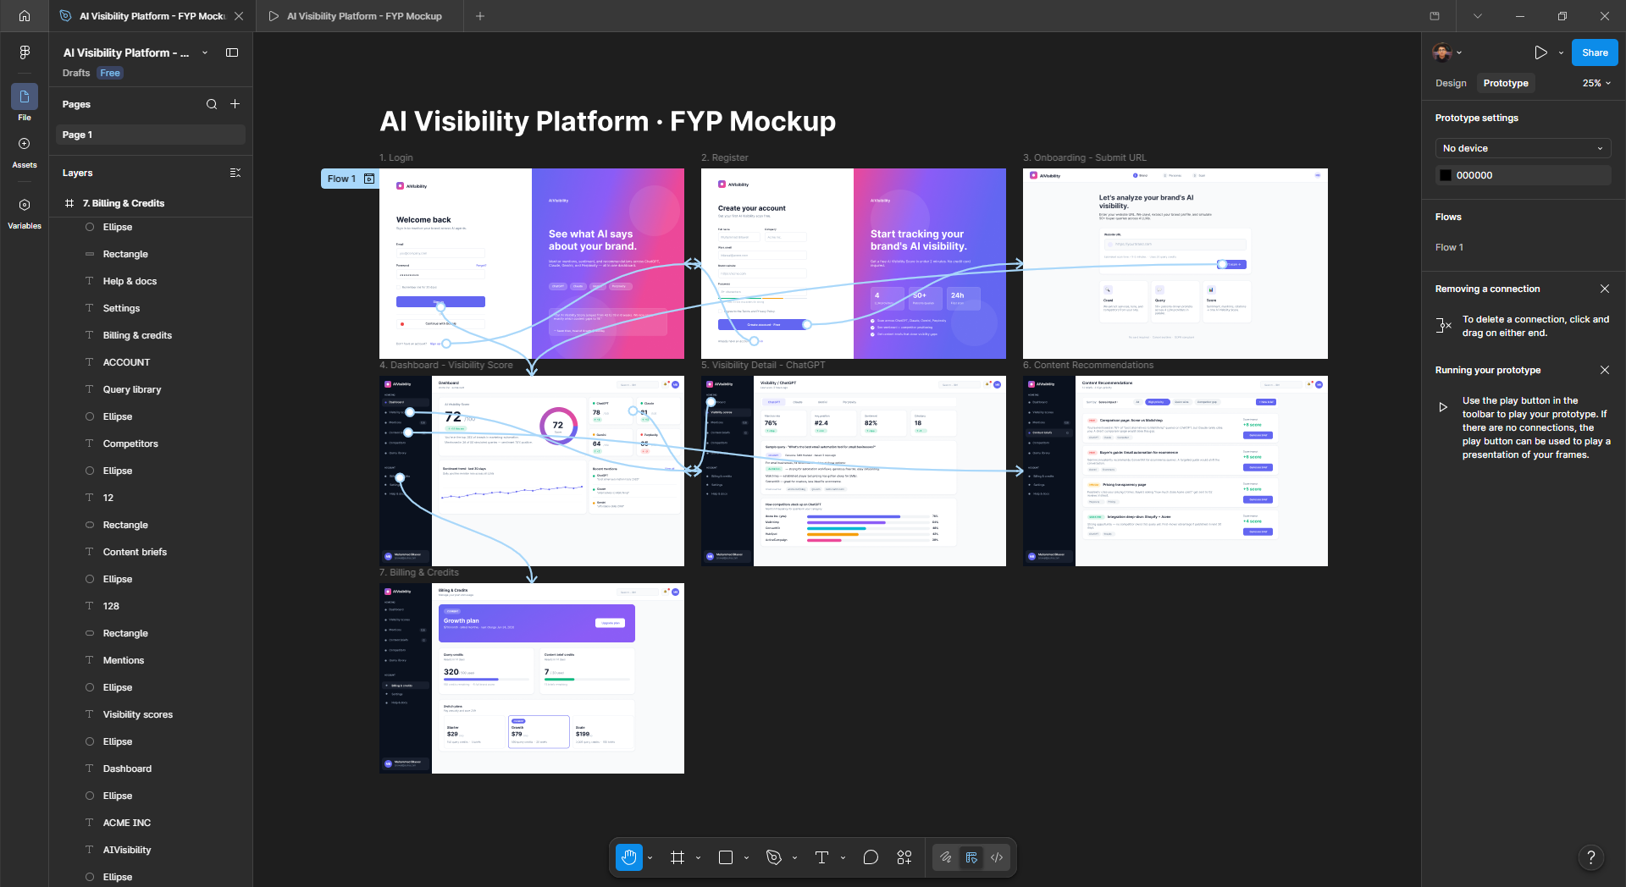
Overview & Methodology
The evaluated prototype is a Generative Engine Optimization (GEO) SaaS platform. It monitors how a brand is mentioned across ChatGPT, Claude, Gemini, and Perplexity, aggregates the results into an "AI Visibility Score", and produces content briefs that close visibility gaps. The interactive Figma prototype contains seven screens: Login, Register, Onboarding, Dashboard, Visibility Detail, Content Recommendations, and Billing.
Cognitive Walkthrough was applied to four user tasks that span account creation, daily monitoring, diagnosis, and acting on system recommendations. Each task step is rated against the four standard CW questions:
Q1 Will the user know what to do? Q2 Will the user notice the correct action? Q3 Will the user understand the system response? Q4 Will the user successfully complete the task?
Legend: Y = Yes P = Partial N = No. Any P or N is followed by a short reasoning note.

Task 1 - New user creates an account and starts the first scan
Path: Login -> "Sign up free" -> Register -> Onboarding -> "Start scan"
Step | Q1  Know? | Q2  Notice? | Q3  Understand? | Q4  Complete?
1.1 Locate "Sign up free" link on Login | Y | Y | Y | Y
1.2 Fill registration form | P | Y | P | Y
1.3 Submit URL on Onboarding and start scan | Y | Y | P | Y

Notes. Step 1.2 - The form requests "Brand website" while Onboarding also asks for the URL; users may be unsure why the same value is requested twice (Q1). The password strength meter reads "Good - add 2 more characters for strong", which is internally contradictory (Q3). Step 1.3 - The prototype does not include a scan-in-progress state, so the user has no visual confirmation that work is happening between clicking Start scan and reaching the Dashboard (Q3).
Issues & fixes. (a) Remove "Brand website" from Register and collect it once on Onboarding. (b) Rewrite strength-meter wording so label and hint agree ("Almost there - add 2 to reach Strong"). (c) Add a "Scanning..." interstitial with per-LLM progress between Onboarding and Dashboard.

Task 2 - Returning user logs in and reads their AI Visibility Score
Path: Login (credentials) -> Dashboard -> read Score
Step | Q1  Know? | Q2  Notice? | Q3  Understand? | Q4  Complete?
2.1 Sign in with email and password | Y | Y | Y | P
2.2 Locate the AI Visibility Score on Dashboard | Y | Y | P | Y

Notes. Step 2.1 - No password-visibility toggle (eye icon) is provided; users typing longer passphrases cannot verify what they typed, raising the risk of failed sign-in (Q4). Step 2.2 - The 64pt score "72" is easy to find, but the gauge ring beside it is decorative - the arc does not visibly correspond to 72%, weakening the at-a-glance read (Q3).
Issues & fixes. (a) Add a show/hide eye icon to all password fields. (b) Drive the gauge fill from the actual score value with banded colour (green / amber / red). (c) Default "Remember me" to checked to reduce friction for returning users.

Task 3 - Investigate a declining platform score (Perplexity)
Path: Dashboard -> Perplexity platform card -> Visibility Detail (Perplexity tab)
Step | Q1  Know? | Q2  Notice? | Q3  Understand? | Q4  Complete?
3.1 Notice the red delta on the Perplexity card | Y | P | Y | P
3.2 Drill into the Perplexity platform | P | N | Y | P
3.3 Read the competitor comparison | Y | Y | Y | Y

Notes. Step 3.1 - The "-3" delta badge is only 11pt and sits at the bottom of the card; among three green deltas it is the most actionable signal but visually the easiest to miss (Q2). Step 3.2 - Platform cards have no chevron, hover state, or "View details" link, so the user may not realise the card itself is clickable (Q1, Q2) and may fall back to the slower sidebar path.
Issues & fixes. (a) Render negative deltas at heavier weight or with a small "Investigate" inline link. (b) Add a hover lift + chevron affordance to platform cards. (c) Add status dots to the platform tabs on Visibility Detail so health is visible at the navigation level.

Task 4 - Act on a HIGH-priority content recommendation
Path: Sidebar -> "Content briefs" -> Recommendations list -> "Generate brief"
Step | Q1  Know? | Q2  Notice? | Q3  Understand? | Q4  Complete?
4.1 Navigate to Content Recommendations | Y | Y | Y | Y
4.2 Identify the right recommendation to act on | P | P | Y | Y
4.3 Click "Generate brief" | P | Y | N | P

Notes. Step 4.2 - The HIGH priority badge uses red, which collides with the conventional "error" colour association; some users will misread urgency as danger (Q2). Step 4.3 - The "Generate brief" CTA sits ~700px to the right of the description, visually disconnected from its context (Q1). The prototype shows no post-click state, so the user does not know whether the brief is being generated, queued, or already opened (Q3).
Issues & fixes. (a) Switch HIGH priority to amber/orange and reserve red strictly for errors and warnings. (b) Place "Generate brief" inline with the card title or as a full-width footer button. (c) On click, show a "Brief in progress" modal that routes to a Brief detail view on completion.

Summary
Across the four tasks, nine usability issues were identified. None block task completion, but the high-severity items materially slow first-time users. Grouped by severity:
High - platform cards lack a clickability affordance; negative deltas under-weighted; no post-action state after "Generate brief".
Medium - duplicate "Brand website" field; contradictory password-strength wording; missing password-visibility toggle; decorative gauge ring; HIGH priority rendered in red.
Low - "Remember me" not default-checked; no scan-in-progress visual.
Addressing the three high-severity items - especially the platform-card affordance and the post-"Generate brief" state - would yield the largest gain in perceived responsiveness and learnability. The remaining items are copy and styling fixes that can be batched into a single visual-polish pass before the next round of user testing.

